[mohmed@localhost work-space]$ cd ..

[mohmed@localhost ~]$ mkdir task2

[mohmed@localhost ~]$ cd task2

[mohmed@localhost task2]$ nano Dockerfile

[mohmed@localhost task2]$ nano Dockerfile

[mohmed@localhost task2]$ nano Dockerfile

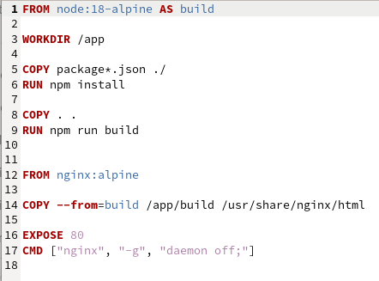

[mohmed@localhost task2]$ docker build -t task2 .

ERROR: permission denied while trying to connect to the Docker daemon socket at unix:///var/run/docker.sock: Head "http://%2Fvar%2Frun%2Fdocker.sock/_ping": dial unix /var/run/docker.sock: connect: permission denied

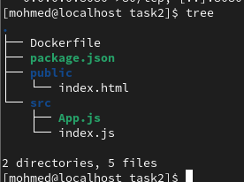

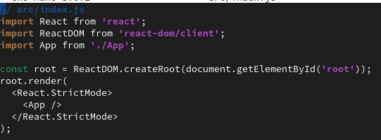

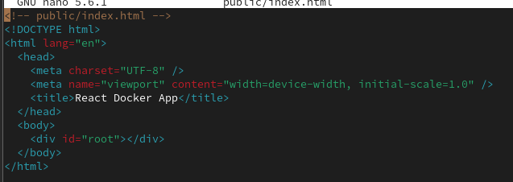

[mohmed@localhost task2]$ sudo docker build -t task2 .

[sudo] password for mohmed:

[+] Building 256.6s (12/13) docker:default

=> [internal] load build definition from Dockerfile 0.0s

=> => transferring dockerfile: 327B 0.0s

=> [internal] load metadata for docker.io/library/nginx:alpine 2.1s

=> [internal] load metadata for docker.io/library/node:18-alpine 3.6s

=> [internal] load .dockerignore 0.0s

=> => transferring context: 2B 0.0s

=> [build 1/6] FROM docker.io/library/node:18-alpine@sha256:8d6421d663b 21.8s

=> => resolve docker.io/library/node:18-alpine@sha256:8d6421d663b4c28fd3 0.0s

=> => sha256:8d6421d663b4c28fd3ebc498332f249011d11894558 7.67kB / 7.67kB 0.0s

=> => sha256:929b04d7c782f04f615cf785488fed452b6569f87c7 1.72kB / 1.72kB 0.0s

=> => sha256:ee77c6cd7c1886ecc802ad6cedef3a8ec1ea27d1fb9 6.18kB / 6.18kB 0.0s

=> => sha256:dd71dde834b5c203d162902e6b8994cb2309ae04 40.01MB / 40.01MB 19.4s

=> => sha256:1e5a4c89cee5c0826c540ab06d4b6b491c96eda0183 1.26MB / 1.26MB 3.3s

=> => sha256:25ff2da83641908f65c3a74d80409d6b1b62ccfaab220b9 446B / 446B 2.1s

=> => extracting sha256:dd71dde834b5c203d162902e6b8994cb2309ae049a0eabc4 2.1s

=> => extracting sha256:1e5a4c89cee5c0826c540ab06d4b6b491c96eda01837f430 0.1s

=> => extracting sha256:25ff2da83641908f65c3a74d80409d6b1b62ccfaab220b9e 0.0s

=> CACHED [stage-1 1/2] FROM docker.io/library/nginx:alpine@sha256:4ff10 0.0s

=> [internal] load build context 0.0s

=> => transferring context: 1.01kB 0.0s

=> [build 2/6] WORKDIR /app 0.1s

=> [build 3/6] COPY package*.json ./ 0.1s

=> [build 4/6] RUN npm install 227.9s

=> [build 5/6] COPY . . 0.0s

=> ERROR [build 6/6] RUN npm run build 2.8s

------

[mohmed@localhost task2]$ sudo docker run -d -p 8080:80 task2

79bab2965c2504e3cb72e211d12a809dc9ca5493e7c796c911a279d403333587

[mohmed@localhost task2]$ sudo docker ps

CONTAINER ID IMAGE COMMAND CREATED STATUS PORTS NAMES

79bab2965c25 task2 "/docker-entrypoint.…" 21 seconds ago Up 20 seconds 0.0.0.0:8080->80/tcp, [::]:8080->80/tcp magical_kepler

[mohmed@localhost task2]$ tree

.

├── Dockerfile

├── package.json

├── public

│   └── index.html

└── src

├── App.js

└── index.js

2 directories, 5 files

